INDIVIDUAL ACCOUNT OPENING FORM

Estate
 |  | Category of Account (tick as appropriate): |  |  | Individual |  |  |  |  |  | Joint
 |  | Title |  |  |  | First Name
 |  | Middle Name |  |  |  | Last Name
 |  | Religion |  |  |  | Gender |  |  |  |  | Male |  |  |  | Female
 |  | Date of Birth |  |  |  | Place/Country of Birth
 |  | (dd/mm/yyyy)
 |  | Marital Status | Married |  | Single | Others
 |  | State of Origin (Nigerians Only) |  |  |  | LGA
 |  | Mother’s Maiden Name
 |  | Residential Address
 |  | Mailing Address
 |  | Date of Entry into Present Residence
 |  | Country of residence |  |  |  | Nationality
 |  | Resident Indicator |  | Resident |  |  | Non-Resident
 |  | Do you carry other country’s passport other than Nigeria? |  |  |  | Yes |  |  |  |  | No
 |  | If yes, state the country________________________________
 |  | Mobile Phone |  |  |  | City Code |  |  |  |  |  |  |  | Country Code
 |  | Landline Phone |  |  |  | City Code |  |  |  |  |  |  |  | Country Code
 |  | Personal Email Address
 |  | ID Type | International Passport |  |  | Driver’s License |  |  |  |  |  |  |  |  | National ID Card
 |  | ID Number |  | Issue Date |  |  |  |  |  |  | Expiry Date |  |  |  | Place of Issue
 |  | Joint Account Holder
 |  | Name of Account
 |  | Relationship with Joint Account Holder
 |  | Name of Joint Account Holder
 |  | Date of Birth (dd/mm/yyyy) |  |  |  |  |  |  |  | Place/Country of Birth
 |  | Residential Address
 |  | Marital Status | Married |  | Single | Others
 |  | Country of Residence |  |  |  |  |  |  |  |  | Nationality
 |  | Mobile Phone |  |  |  | City Code |  |  |  |  |  |  |  |  | Country Code
 |  | Landline Phone |  |  |  | City Code |  |  |  |  |  |  |  |  | Country Code
 |  | Personal Email Address
 |  | ID Type | International Passport |  |  | Driver’s License |  |  |  |  |  |  |  |  | National ID Card
 |  | ID Number |  | Issue Date |  |  |  |  |  |  | Expiry Date |  |  |  | Place of Issue
 |  | Employment Details
 |  | Level of Qualification
 |  | Employment Status | Full-time | Part-time |  |  | Retired |  |  |  |  | Self Employed |  |  | Others
 |  | Occupation/Employment Segment |  |  |  |  |  |  |  |  |  | Appointment Date
 |  | Company Name
 |  | Company/Office Address


RC 185376

Member of The Nigerian Stock Exchange www.rostrumsec.com

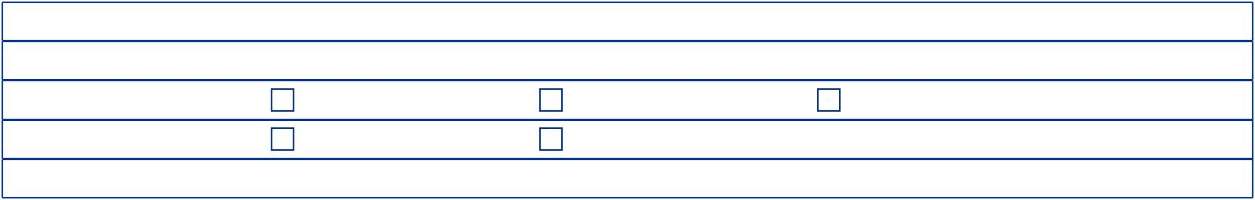 |  | Official Telephone Number |  |  |  |  |  |  |  |  |  | Fax Number
 |  | Official Email Address |  |  |  |  |  |  |  |  |  | Official Website Address
 |  | Annual Average Income |  |  |  |  | Less than N10m |  | N10 - 50m |  |  |  |  |  |  | N50m and Above
 |  | Source of Investment Fund |  |  |  |  | Employment |  | Business |  |  |  |  |  |  | Others
 |  | Purpose of Investment
 | Bank Account Details (Your Bank Account Name Details Should Correspond With CSCS Account Name).
 |  | Bank Name |  |  |  |  |  |  |  |  |  | Branch
 |  | Account Name |  |  |  |  |  |  |  |  |  | Account Number
 |  | Bank Verification Number |  |  |  |  |  |  |  |  |  | Date of Creation (Of Bank Acct)
 |  |  | Next Of Kin Details
 |  |  | Title |  |  |  |  |  |  |  | First Name
 |  |  | Middle Name |  |  |  |  |  |  |  | Last Name
 |  |  | Date of Birth |  |  |  | Nationality |  |  |  |  |  |  | Gender |  | Male |  |  | Female
 |  |  | Relationship |  |  | Parent | Child |  | Spouse |  |  |  |  | Others
 |  |  | Email |  |  |  |  |  |  |  |  |  |  | Telephone Contact
 |  |  | Contact Address of Next of Kin
 |  | For Minor Only
 |  | Name of Minor
 |  | Date of Birth |  |  |  |  |  |  |  |  |  |  |  | Gender |  |  | Male |  | Female
 | Questionnaire
 | Have you occupied any Political Position? |  |  |  |  |  |  | Yes |  |  | No | If yes, please state the most recent political position occupied
 |  |  |  |  |  |  |  |  |  |  | Date: From |  |  |  |  |  |  | To
 | Have any of your close relatives/associates occupied a Political Position? |  |  |  |  |  |  |  |  |  |  | Yes |  | No
 | If yes, please state the names and your relationship with such persons below
 | 1. |  |  |  | Name |  |  |  |  |  | Relationship
 |  |  |  |  | Position Held |  |  |  |  |  | Date: From |  |  |  |  |  |  | To
 | 2. |  |  |  | Name |  |  |  |  |  | Relationship
 |  |  |  |  | Position Held |  |  |  |  |  | Date: From |  |  |  |  |  |  | To
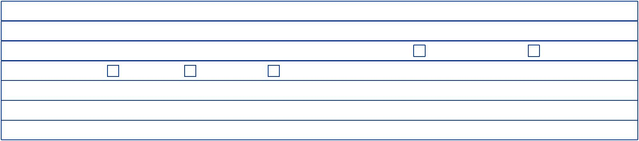
Attestation

I/We attest that all information provided herein is accurate and would notify you to update my/our records where any change occurs

Name, Signature and Date Name, Signature and Date
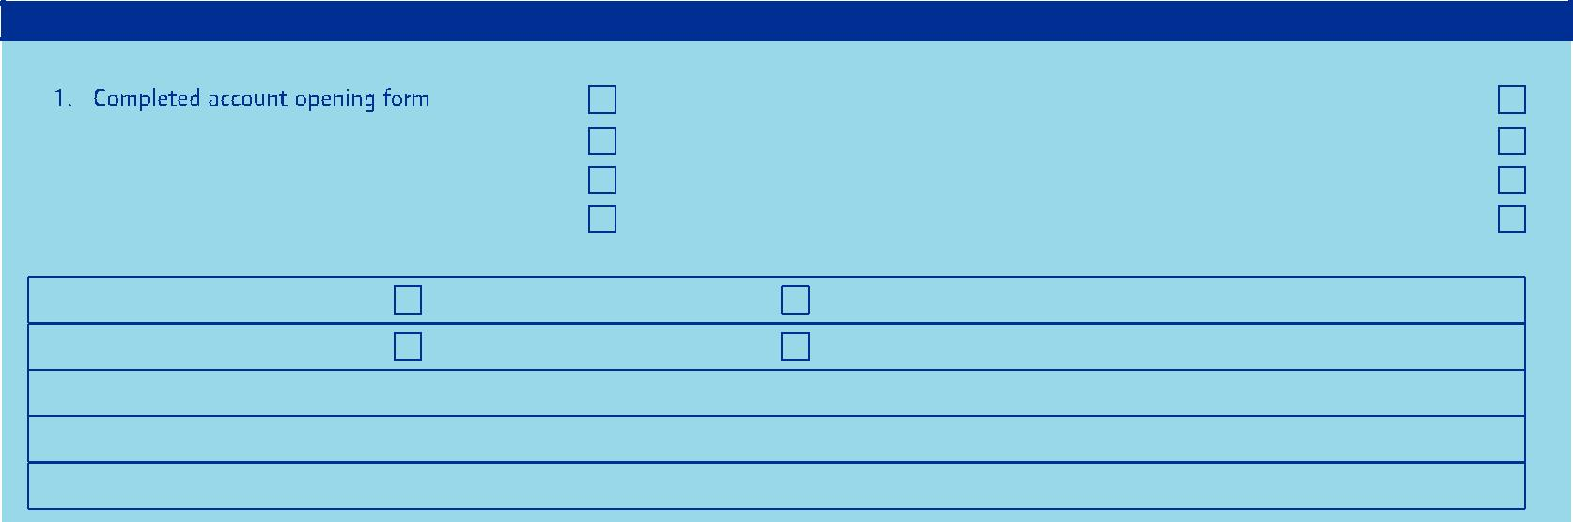
For Official Purpose Only

Documentation Checklist

 |  | 5. | *Proof of address (e.g. copy of recent utility bill)
2. | Standard terms and conditions | 6. | Resident permit (for Non-Nigerians)
3. | Passport photograph | 7. | *Birth certificate (for minors only)
4. | *Means of identification | 8. | Safe watch list report

* Originals must be sighted

Document Status | Complete | Incomplete
Risk Rating | Low | High
Account Opening Authorized By
Date
CSCS Number |  | Account Number

TERMS AND CONDITIONS

SECTION A:

- Rostrum Investment and Securities Limited’s (RISL) office is open for business between the hours of 8 a.m. and 5 p.m. on each day that is designated a business day in Nigeria ("business day).

- Clients' mandates can be received in person by bringing it to office. Mandates can also be sent to the dedicated email address for mandates via customercare@rostrumsec.com

- The deadline for the receipt of clients' mandates via all channels is 9 a.m. on the intended business day of execution.

- In the absence of an express instruction as to a specific timeline for the expiration of clients' mandates, the mandate will be valid for 5 Days upon receipt by RISL, after which it expires and the unexecuted portion will be automatically cancelled.
- Amendments/cancellation of mandates can be done via either the online brokerage account or via e-mail to customercare@rostrumsec.com or through an official letter. This is also subject to the deadline in (3) above.

- Where mandates/amendments/cancellations are submitted after the deadline stated in (3) above, the mandates/amendments/cancellations may not be treated until the next business day.

- Mandates / amendments /cancellation received on a day that is not a business day will be deemed to have been received on the business day immediately following the day of actual receipt.

- Where a mandate consists of a purchase instruction, it can only be treated if sufficient funds are available in the client's stockbroking account to execute such an instruction.

- Where a purchase mandate is dependent on the sales proceeds of stocks, the purchase mandate may not be executed until the sales transaction has been executed. The sale mandate will be executed even if the stocks to purchase are not available.
- Purchase of Stock into client unfunded account is allowed only in cases where there is a formal approval from the appropriate authorities and it must not exceed four days, transactions day plus three days (i.e. T + 3).
- Where the execution of the valid mandate throws the account into debit and overdraft position is treated. Any sum standing to the debit of the client account as a result of this overdraft position and not liquidated after four days (3 days) shall automatically liable to interest charges at a prevailing market rate. Rostrum Investment and Securities Limited is authorized to debit client account with usual charges, commission and interest for such facilities.

- RISL is acting as execution-only stockbroker and not financial advisors or portfolio manager. Consequently, RISL will only execute BUY and SELL mandates given by the client on the floor of The Nigerian Stock Exchange.

- RISL executes transactions based on the ruling market prices of stocks on The Nigerian Stock Exchange at the time of execution.

12. RISL executes mandates on a best efforts basis only. It is therefore unable to guarantee that a mandate will be executed on a particular day even where such mandate indicates that the relevant transaction is to be effected at "market price".
- Buy and sell mandates can only indicate one price and not a price range. You will be advised of the outcome of your mandate via e-mail. Where this is not received by close of business on the next working day after you submitted your mandate, kindly contact RISL via email to customercare@rostrumsec.com

- All sales proceeds of stocks sold shall be retained in the client's stockbroking account except if otherwise advised (expressly) by the client.
- Transaction settlement on The Nigerian Stock Exchange is done on a trading day plus three days (i.e.T + 3) in compliance with this regulation, payment for consummated sales mandates is on a trading day plus four days consideration, Rostrum Investment and Securities Limited pays in crossed cheques written in the beneficiary whose name appears on the shares certificate or account holder. The acceptable means of identification here is current Driver’s License, National Identification card or a current International passport.
- Funds deposited into client's stockbroking account with RISL including retained proceeds of sales is not interest bearing. A client's fund will remain in the client's stockbroking account until an expressed instruction/mandate is received authorizing the utilization of the fund or withdrawal of the fund

- Requests to withdraw funds from client's stockbroking account will only be honored if there are adequate cleared and unencumbered funds in the client's stock broking account with RISL. Associated transfer charge(s) for interbank transfers will be borne by the client.

- RISL shall not make any payment from a client's stockbroking account to a 3rd party even if such payment have been authorized by the account holder.
- To facilitate prompt verification of certificates, clients should endeavor to attach copies of share application form, dividend warrants and banker’s confirmation of the client’s signature as the case demands. Rostrum Investment and Securities Limited will not be responsible for verification delays due to incomplete documentation, irregular signature issue or any other reasons outside its sphere of control.
- I/We understand that all mandates, amendments, cancellations, transfer and withdrawal requests sent after the specified deadlines may not be treated till the next business day as specified above. RISL is not under any compulsion to treat any of the referenced instructions sent after the deadlines; however in event that such instructions are treated despite having been received after deadline by RISL, the instructions shall be binding upon me/us

- RISL can be contacted via e-mail: customercare@rostrumsec.com, telephone: +234-(0)909-998-4876, +234 (0) 709-873-2206, +234 (0)709-812-0604.

SECTION B:

In Consideration of your Rostrum Investment and Securities Limited (RISL) having agreed to accept and to act on my/our instructions given via e-mail, online brokerage account and other electronic channels (without requiring a written confirmation bearing my/our actual signatures in accordance with my/our mandate) in respect of any transactions regarding my/our account with RISL, I/We hereby confirm that:

- I/We hereby appoint RISL as my Stockbroker and also authorize them to open or close my brokerage account, place and withdraw orders and take such other steps incidental to this authority.
- I/We understand that it is my/our responsibility to keep my/our profile details

(User name, password and other electronic channel details) as private and confidential to prevent unauthorized access to my/our stockbroking account with RISL.

- I/We understand that it is my/our responsibility to notify RISL where I/we detect that my/our profile details (User name, password and other electronic channel details) have been compromised. I/We also understand that any transaction executed on my/our account before RISL is notified of such compromise is binding on me/us.

- RISL is authorized to act on instructions, which have been transmitted via any of the referenced electronic channels without bearing my/our signature (s) provided such instructions emanated from my/our registered details in RISL's records.
- RISL shall not be under any duty to verify the identity of the person(s) giving instructions in my/our name provided such instructions have emanated from my/our registered details in RISL's records and any transaction made pursuant to the instructions shall be binding upon me/us.

- Except my/our instruction sent via any of the referenced electronic channels is duly revoked or modified by a subsequent instruction issued by me/us and such subsequent instruction has been communicated to and received by RISL before the execution of the prior instruction and within the stipulated deadline for revocation and or amendment of instructions, I/We undertake to be bound irrevocably by such prior instruction.
- RISL shall not be liable for losses, errors, omissions, delays in the operation of the account or the transmission of orders caused directly or indirectly by war, natural disasters, government reactions, exchange or market rulings, breakdown of transmission or communication equipment and other conditions beyond its control.

- I/We understand that where a mandate/instruction is sent via e-mail to customercare@rostrumsec.com, I/We should receive an auto generated acknowledgment e-mail immediately. Where this is not received within 30 minutes, I/We understand that I/We should immediately contact RISL to confirm receipt of the mandate/instruction.

- I/We understand that upon submission of my/our mandates/ instructions placed via my/our online brokerage account or my registered email address, it is my/our responsibility to confirm that such mandates/ instructions have been successfully submitted and are reflecting on my/our online outstanding order module. Where the mandates/instructions are not reflecting, I/We understand that I/We should immediately contact RISL to confirm receipt of the mandate/instruction

- I/We hereby agree to keep RISL indemnified from and against all actions, proceedings , claims and demands which may be brought or made against RISL and all loses, costs, charges, damages and expenses which may be incurred or sustained or for which RISL may become liable by reason of honoring such e-mail, online brokerage account and other electronic channels instructions provided that RISL has taken all measures prescribed by this agreement irrespective of whether the instructions are in fact erroneous, fraudulent or issued otherwise than as foresaid.

Confirmation

I/We declare that the information given in the account opening forms is true and correct. We agree that any information found to be false may cause RISL to decline the application or close the account if it has been opened. Should any details change in the future, e.g. address, name of Company etc. I/We shall inform you promptly.
I/We have read and agree to be bound by the above terms and conditions and indemnity.

Name of Account Holder:___________________________________________

Signature of Account Holder: ________________________________________

Name of Joint Account Holder: _______________________________________

Signature of Joint Account Holder: ____________________________________

Dated this __________________ day of __________________ 20_________

RC 185376

Member of The Nigerian Stock Exchange www.rostrumsec.com

